Emmy Voita

CST-310

Professor Citro

January 29, 2023

##### 

##### 

##### 

##### 

##### 

##### 

##### 

##### 

##### 

##### 

##### 

##### \

##### 

##### **Project 2: Your Surrounding World**

For this project, the goal was to obtain 6 images from 3 distinct environments. Due to the difficulty of replicating some objects in OpenGL, such as reflections or semi-transparent materials, it is important to choose each scene with intention. As we are tasked with creating scenes that are not overly complex, but also are not too trivial, I tried to include a mix of mostly simple geometry along with a couple complex items. I came across some difficulty setting up different scenes that would not be overly difficult to recreate, so I added variations into scenes through reflections or perspective. Each of these pictures are my own.

**Scene 1:**

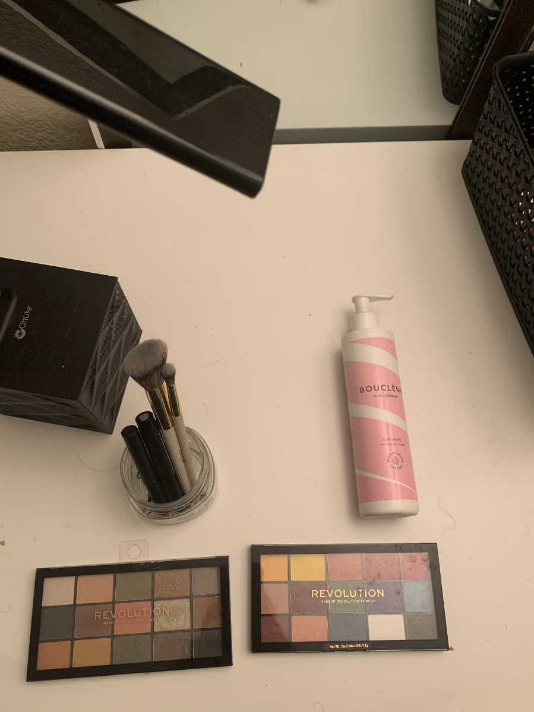

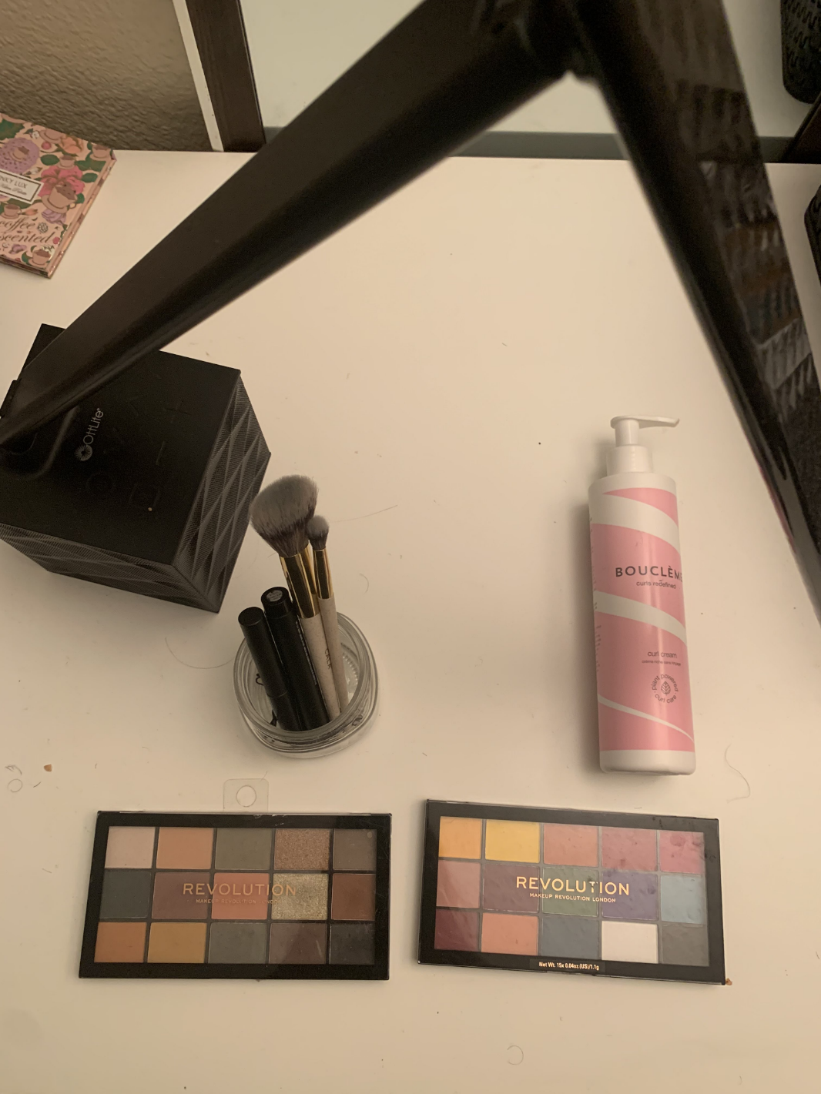

Scene 1 contains multiple objects that have a variety of different colors but aren’t too complex in shape. For example, the eyeshadow palette consists mainly of multiple rectangles of different colors, alongside the brand name. Similar to the following two scenes, this scene contains multiple objects placed on a table. To add some variation from the other scenes, this scene contains multiple reflections. While typically reflections would be difficult to replicate in OpenGL, these reflections do not contain a lot of detail. It is also notable that the table texture in this scene could be recreated from a solid color, rather than requiring either sampling a texture in a shader or using brute force. I also placed the lamp close to the camera to add some perspective.

**Scene 2:**

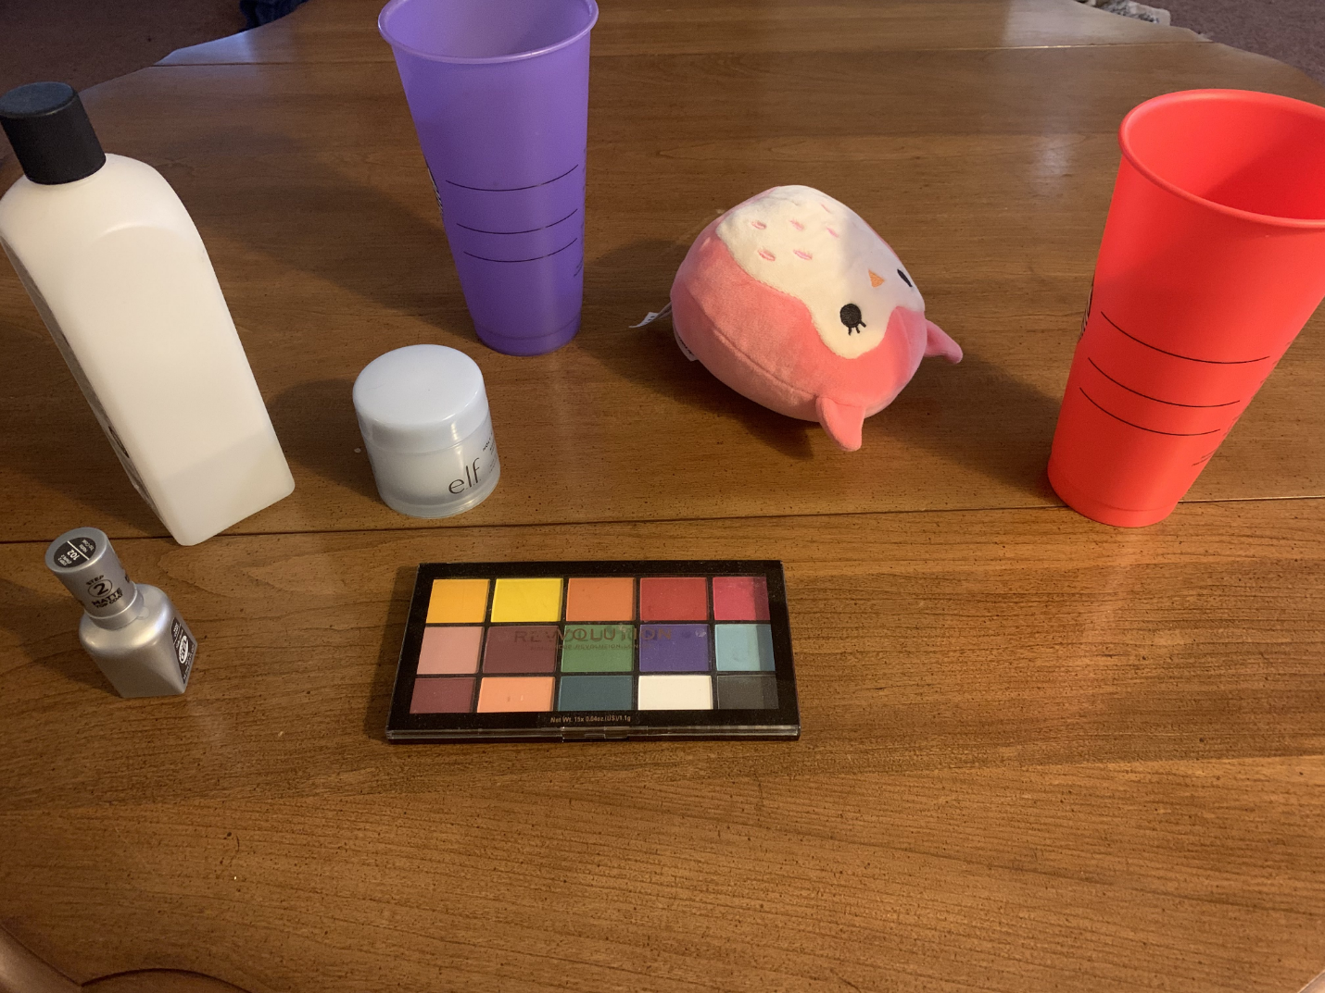

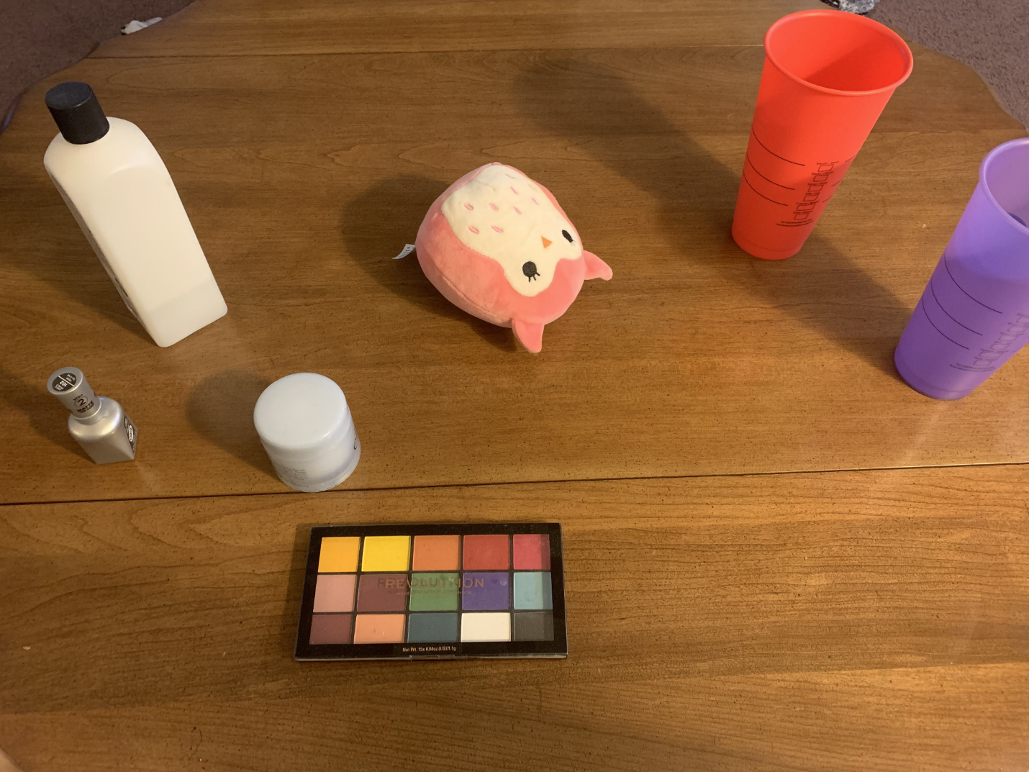

Scene 2 includes both easy and difficult objects to recreate. Most of the objects are simple in shape and lack a lot of detail. However, there are two outliers, those being the owl plushie and table. The lighting in this scene would not be that hard to recreate as there is only 1 light source and none of the objects are very reflective. Also, there are a couple objects in this scene that contain a lot of color that would be interesting to recreate.

**Scene 3:**

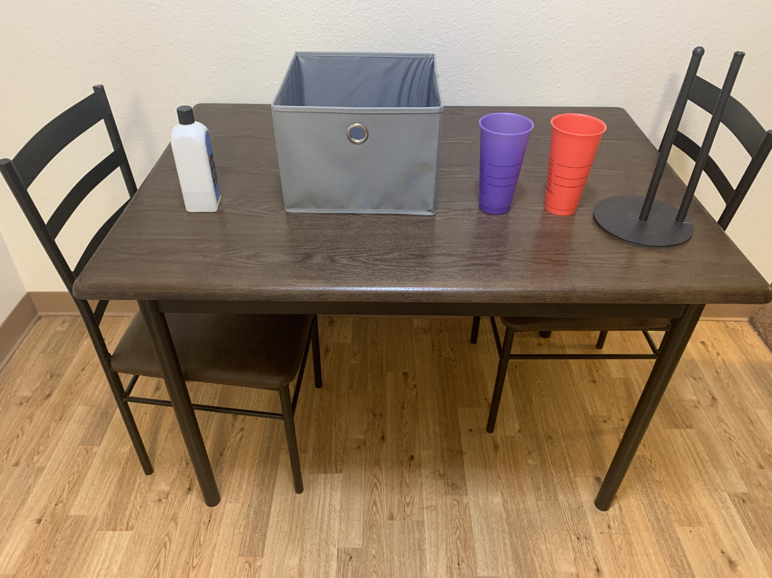

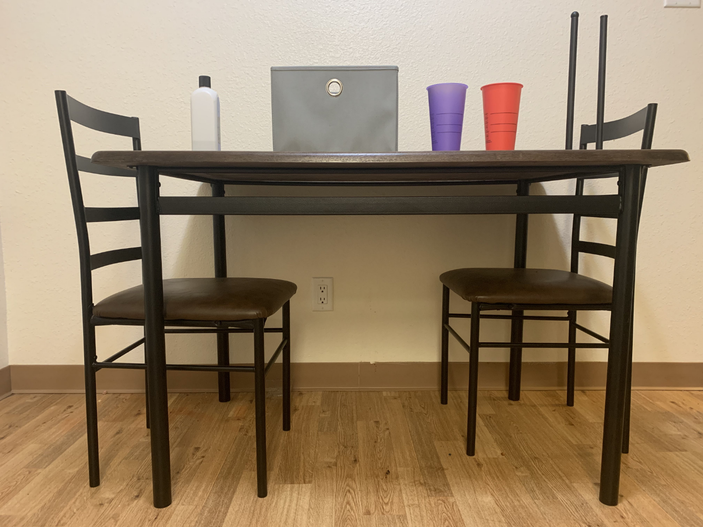

Scene 3 features a mix of simple and complex shapes, such as the table and chairs which are mostly composed of rectangles with minimal curvature. Although, there are some aspects to the scene which would be difficult to recreate. For one, there is curvature of the fabric on the bin in the first image. Secondly, the wall, wood floor, and table textures are very detailed. Finally, there are some reflections seen in the chair cushion as well as tabletop that would be difficult to replicate, making the second image for this scene considerably easier to reproduce.

##### **Project 3: Your Surrounding World**

The first image of the second scene was chosen to be recreated for project 4. The second image below shows how the scene could be recreated using primitive shapes, and the third image is a crude model of the scene made in blender to provide another perspective.

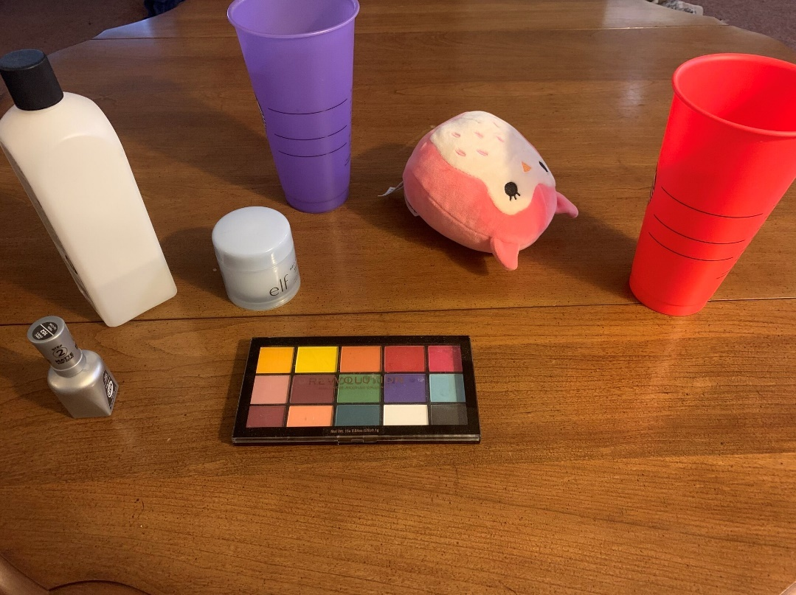

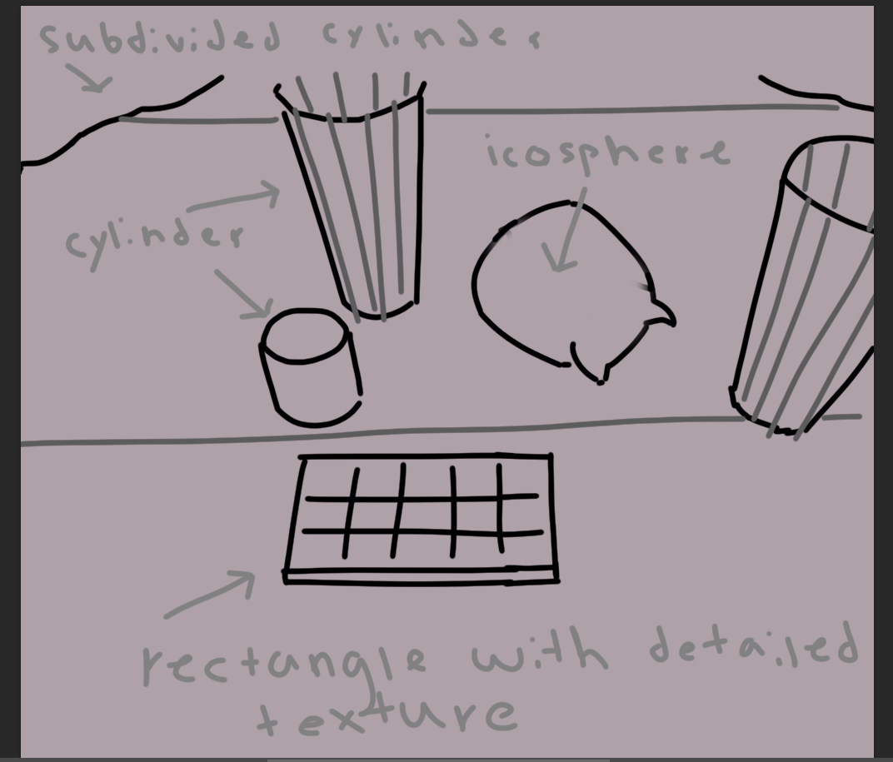

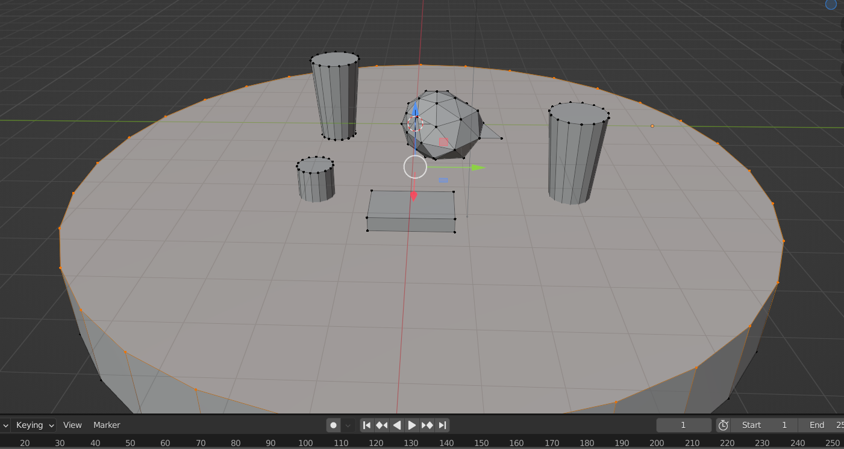

**Listing objects in the foreground, background, and in between:**

Objects in foreground:

* Cups x2
* Nail Polish
* Nail Polish Remover bottle
* Makeup remover jar
* Eyeshadow palette
* Owl plush

Objects in between:

* Coffee Table

Objects in background:

* Carpet

**Main objects in the scene:**

* Coffee Table
* Cups
* Eye shadow palette
* Owl plush
* Paper towels

**Key scene characteristics:**

* There is a light source coming from the side of the scene.
* 3 of the foreground objects are desaturated, while the other objects are very saturated.
* There is a reflection off of the table, but not off of any of the objects
* Some objects have a high amount of detail, while others do not.

**Method for rendering each object in the scene:**

My plan for rendering objects into the scene will consist of the following steps:

* Recreate each object in blender including a texture for the object.
* Export the object as a .obj file and texture as a png.
* Use a c++ function that reads in the .obj file and saves the positions, uvs(texcoord), and normals into a Vertex data struct that is then passed into the vertex shader.
* Pass the corresponding texture to be sampled into the fragment shader.

While this approach may be more difficult to implement than simply recreating the objects by hand, it will save a significant amount of time and will make it significantly easier to add additional items to the scene.

**Difficulty ranking of each object in the scene:**

Given the included approach works, only three objects would be difficult to recreate in blender, those being the table, owl plush, and eyeshadow palette. The table texture and eyeshadow palette would be difficult to replicate by hand given the amount of detail and the owl plush shape would be difficult to recreate as it doesn't exactly fit a primitive shape. All the other objects would be of similar difficulty except for potentially the carpet. Although, the carpet texture could easily be recreated by interpolating between two colors using noise.

**Project 4:** **Render Your Scene With Primitives**

***Objects Rendered in OpenGL:***

Each object in the scene was modeled in Blender. Recreating each object in blender was relatively easy as I have a little bit of experience using the program from previous projects that I have worked on. The main issue with translating hand art to OpenGL was passing that data that I read from files into the shaders. I consistently ran into issues with binding textures. Many times textures wouldn’t be passed to the shader correctly, or the incorrect texture would be passed. Upon further inspection, I found an issue in the order I was calling functions in my MyModelClass.render function where I was rendering the models before binding the textures to their correct uniforms.

***3D Primitives:***

The MyMeshClass header file defines several functions that can be used to apply transformations to a mesh’s model matrix. These transformations get applied in the updateModelMatrix function which is called each frame:

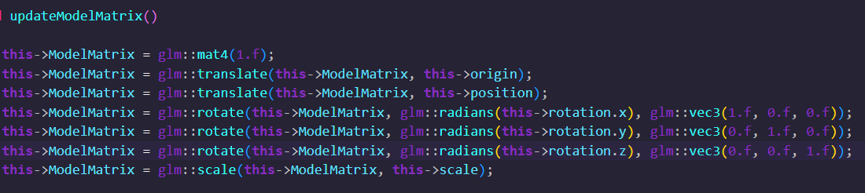

Here are the following Transformations that get applied to the models in Project4Main.cpp:

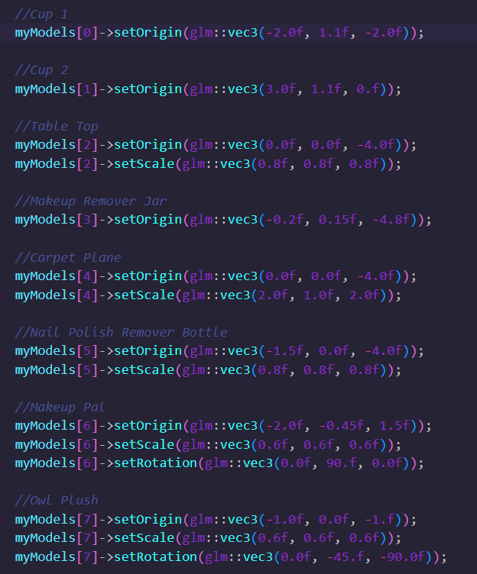

***Mathematical Characteristics:***

There are not any mathematical formulas used to render models/create meshes, instead each object in the scene is created using Blender and read into Vertex structs by their Wavefront (.obj) file.

**Steps for Creating Each Object:**

1. Divide the hand drawn object into basic shapes.
2. Create basic shapes in blender and add more detail to form the model.
3. Use the triangulate modifier on the object as the OBJLoader header file only recognizes triangles.
4. UV unwrap the model.
5. Either create a texture in blender to use for the model or find a separate texture online.
6. Export the model as an .obj file.

***OpenGL Primitives:***

When importing an object file in the OBJLoader class, the object file’s face data orders its vertices to form triangles. The parameter GL_TRIANGLES in the glDrawArrays or glDrawElements function specifies the primitive type to be used for rendering the vertices. GL_TRIANGLES is passed as the primitive type for OpenGL to recognize that every three vertices in the vertex array or index array create a triangle. The following lines of code are found in the MyMeshClass header file in the render function:

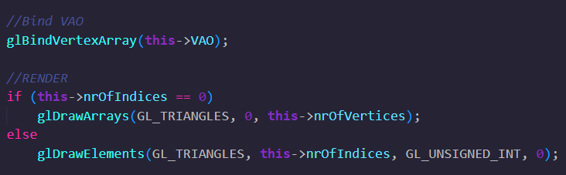

**GL_TRIANGLES:**

specifies that each group of three vertices represents a separate triangle.

**GL_UNSIGNED_INT:**

specifies the data type of the indices array used to index into the vertex buffer.

***Shaders:***

**simpleDepthShader:** This shader is used to render the scene from the lights perspective to generate a texture to be used in the second pass’s fragment shader [either BaseFragmentShader.frag, or AdvancedFragmentShader.frag] for calculating shadows.

**BaseVertexShader.vs:** This vertex shader takes in the data extracted from the Blender .obj file and passes that information on to be used in the fragment shader.

**BaseFragmentShader.frag:**  This shader calculates lighting using the Blinn-Phong lighting model. Each output fragment is defined by a combination of the calculated ambient, diffuse, and specular values. This shader was originally designed to be used strictly for the plastic cups as it modifies the object normals by sampling a noise texture to add a bit of texture to the material. However, this is my default shader as I look for textures to use for the more advanced fragment shader for Project 5.

**AdvancedFragmentShader.frag:**  This shader is essentially the same as the BaseFragmentShader.frag, except that it has more input textures. The functions used in this fragment shader are expanded upon in the Shaders and Concepts They Are Based On section.

***Diagram showing the 3D Geometry of the Camera:***

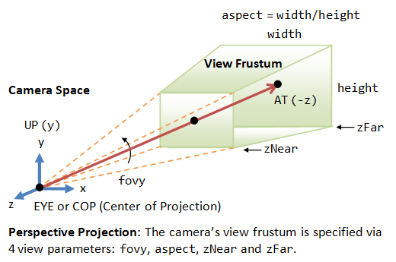

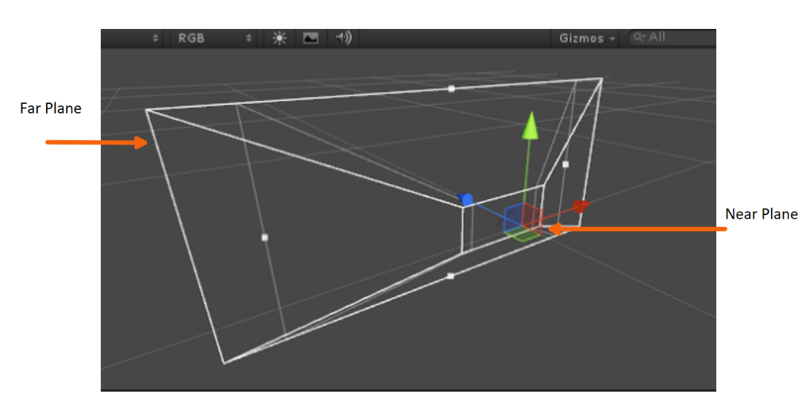

The above image is an example of a projection camera in Unity using the camera gizmo. In Unity, the camera inputs for defining the projection matrix includes the field of view, near plane distance, and far plane distance. In OpenGL, the gluPerspective is used to set up a perspective projection matrix. The parameters of this function include the following:

**FOV:** specifies the angle of the vertical field of view in degrees.

**aspect ratio:** This is the ratio of the width to the height of the view frustum.

**zNear:** This is the distance from the camera to the near clipping plane. Objects that are closer to the camera than this distance will be clipped (i.e., not visible).

**zFar:** This is the distance from the camera to the far clipping plane. Objects that are farther away than this distance will be clipped.

***Shaders and Concepts They Are Based On:***

**Rendering Approach:**

Each model in the scene is loaded from an object file that is extracted from a model created in Blender. This object file contains vertex, normal, texcoord, and face data, which are then read by the ObjLoader header file into Vertex structs. Using these vertex structs, an instance of a mesh class is constructed that contains functions for translation, rotation, scaling, and other adjustments that can be invoked in the main to modify any model.

To render objects in the scene, the first step is to execute a shadow pass. This pass generates the scene's depth buffer from the perspective of the lights and renders it onto a 1024 x 1024 texture for use in the second pass. In this pass, only the vertex information for each model is passed to the vertex shader.

In the second pass, all components of the model class are passed to the shader. When using the base fragment shader, an instance of a model class comprises a mesh class, diffuse texture, material class, shadow pass texture, and a reference to the view matrix. A material class contains data that can be used to modify how a model is illuminated in the scene, such as a multiplier for ambient light, specular light, or alpha. When using the advanced fragment shader, an instance of a model class also has a reference to normal, displacement, gloss, and roughness textures. These additional textures are utilized to add more details.

The AdvancedFragmentShader.frag shader can be broken down into the following functions:

**Calculate Bump Map:**

1. Sample the height map texture and multiply it by a scaling factor.
2. Sample the normal map texture and convert it to view space.
3. Combine it with the input normal data.
4. Create the TBN matrix.
5. Apply the height offset to the vertex position and sample the perturbed normal.
6. Apply the TBN matrix to the perturbed normal vector.
7. Interpolate between the perturbed normal and the original normal based on the height offset and return the final normals.

**Calculate Specular (Blinn-Phong):**

1. Sample the roughness map texturing and offset it by a factor to push values closer to 1.
2. Clamp the roughness value between 0 and 1.
3. Calculate the specular constant using the angle between the light to fragment and view to fragment vectors.
4. Adjust the pow exponent by the roughness value.
5. Compute the final specular highlight color by multiplying the material's specular color, the specular constant, and the color of the light source.

**Calculate Ambient:**

1. Multiply the light source color by the material ambient scalar.

**Calculate Diffuse:**

1. Calculate the direction of the light source from the surface point.
2. Calculate the dot product of the normalized surface normal vector and the normalized light direction vector to get how directly the light is hitting the surface.
3. Clamp the value between 0 and 1.
4. Multiply the calculated diffuse value by the material’s diffuse scalar.

**Shadow Calculation:**

1. Perform perspective divide on the position of the fragment as seen from the light’s perspective.
2. Transform the normalized position to the [0,1] range.
3. Test to see if the fragment is behind the light source by testing the z component of the normalized position. If it is greater than 1, then return 0.
4. Else, get the closest depth value from the light’s perspective.
5. Calculate the depth of the current fragment from the light's perspective by taking the z component of the normalized position.
6. Calculate a bias value from the angle between the surface normal and the fragment position to the light source vector.

[Add a slight gradient to the edge of the shadow]

1. Loop over a 3x3 area of the shadow map and calculate the depth value for each texel in the area. The depth value is compared to the depth of the current fragment plus the previously calculated bias to determine whether each texel is in shadow.
2. Divide the sum by 9 to get an average of the shadow value over the 3x3 area.

###### **Screenshots:**

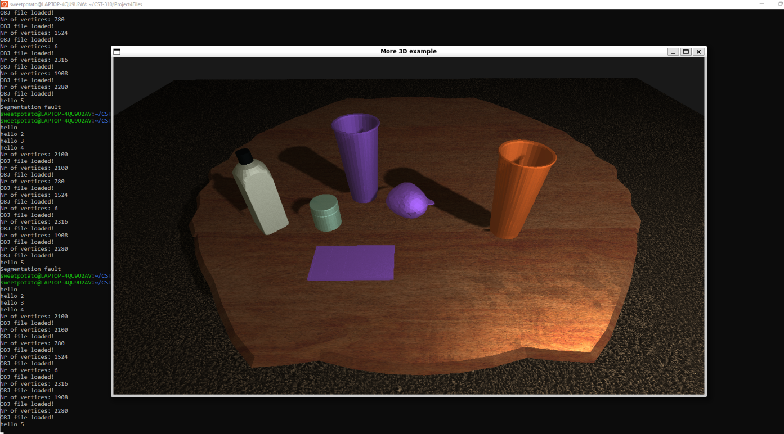

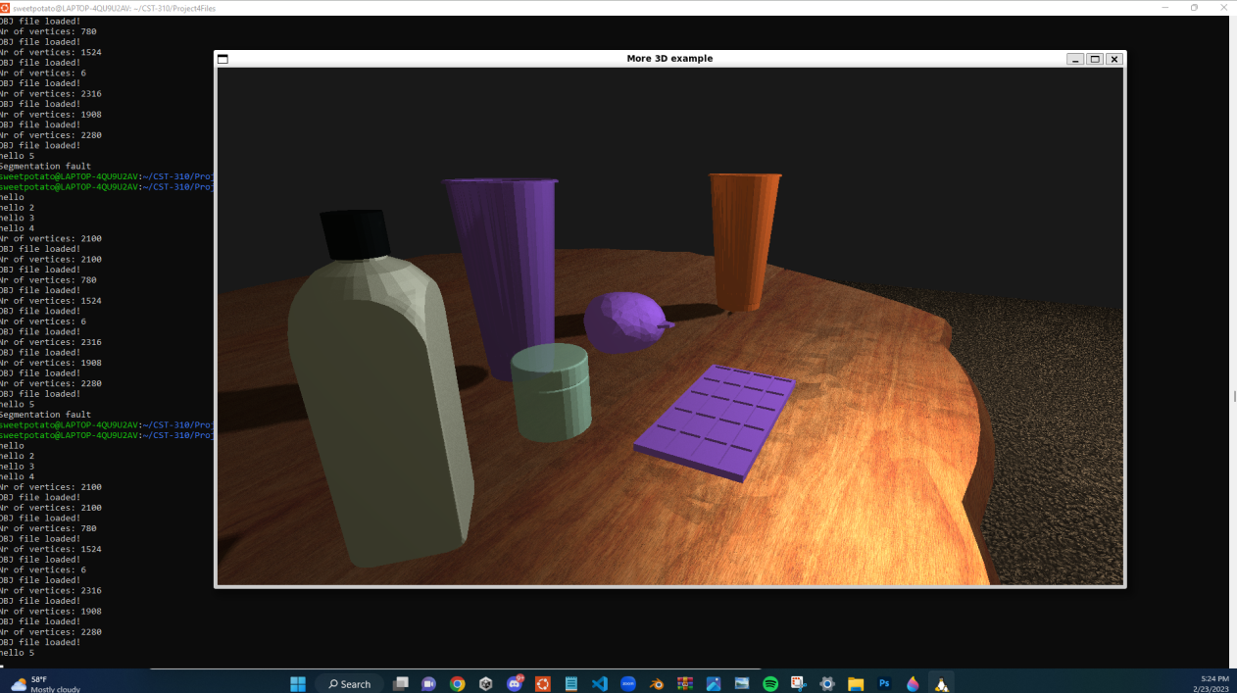

***Next Steps:*** There are several areas to expand upon for project 5. For one, I will locate appropriate textures for the objects that currently utilize the basic fragment shader, with the goal of upgrading them to use the advanced fragment shader. Additionally, I aim to explore the implementation of screen space ambient occlusion (SSAO) and experiment with a potential fur shader for the carpet. Unfortunately, I was unable to resolve the issue of peter panning with the shadows, so I intend to further research on how to resolve that.

***Project 5: Render Your Scene with Primitives***

For project 5 I attempted to implement screen space ambient occlusion (SSAO) along with upgrading some of the scene objects textures. Unfortunately, I was unable to implement the SSAO, but I will expand upon my attempt in detail and what changes I made from project 4 to try and get the program to work.

**SSAO:**

SSAO is a technique in computer graphics that is used to add realistic depth and shading to a scene. It calculates the amount of occlusion between nearby surfaces to simulate the effect of ambient lighting from objects that are close to one another.

Typically SSAO is implemented in deferred rendering, as it requires information that is not available when using traditional forward rendering. To acquire the necessary texture information in forward rendering requires rendering the scene multiple times, which quickly becomes very expensive. In deferred rendering the scene is rendered to multiple textures, such as a normal buffer, depth buffer, and color buffer, that allows for a significantly faster computation of post processing effects like SSAO. This is known as a g-buffer and here is an example of what that looks like:  
  
  
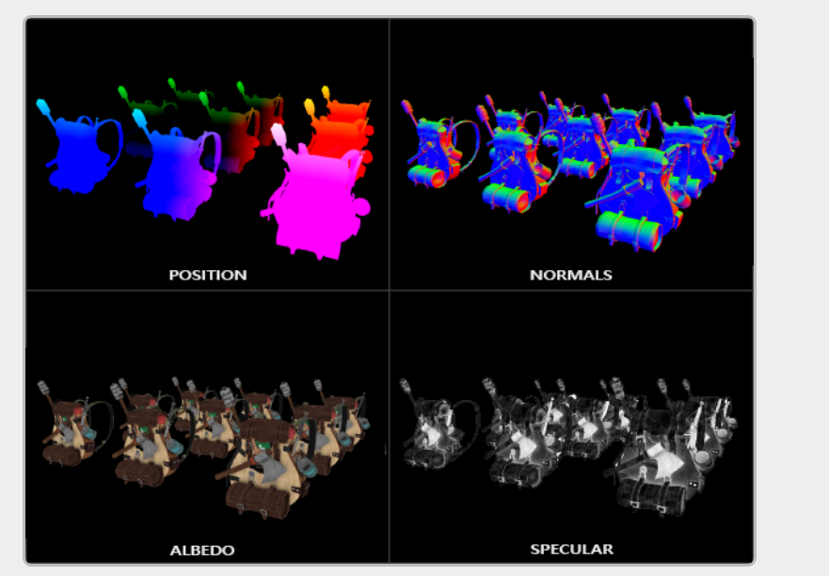

As I wrote my project 4 to use the forward rendering pipeline, I decided to try and implement SSAO in forward rendering as I believed that it would be more difficult to try and rewrite my code to use deferred rendering.   
 **Here is the approach that I took to implementing that in my project:**

* Render the scene as normal, including lighting and shading to a texture.
* Render the depth of the scene to a texture using a vertex and fragment shader.
* Generate a screen-space position texture using the depth texture and the inverse of the projection matrix.
* Render a full-screen quad, using a fragment shader to perform the SSAO calculations based on the depth texture, the position texture, and a function to calculate noise. The output of this shader is the final SSAO texture, which can be combined with the original scene using a post-processing step.
* The post-processing step combines the scene texture and SSAO texture to achieve the desired result.

**Here are what changes I made to attempt to implement those steps:**

* Instead of rendering the scene to the screen, I render the screen to a texture bound to a frame buffer object.
* I created a “SSAOPassClass.h” that renders the screen-space position to the xy channels of a texture and the depth to the z channel of the texture.
* I created a fragment shader that performs the SSAO calculations on the depth texture and then combines that with the scene texture.

Unfortunately, I was unable to get my shader that renders both the screen-space position and depth to a texture to work. There is likely an issue with the texture format, and I believe that if I rendered the information to two separate textures, it would likely work. However, I can clearly see that the performance of the program is declining, and wanted to avoid having to render the scene objects an additional time if possible.

Initially, I applied the SSAO texture to the objects in the scene without realizing that it should have been applied in screen-space. Despite this incorrect application, I believe that my code should work if I am able to correctly pass the necessary data. Here is some the output that was generated from earlier in development:

